**ODIN II**

**Weekly Progress Reports**

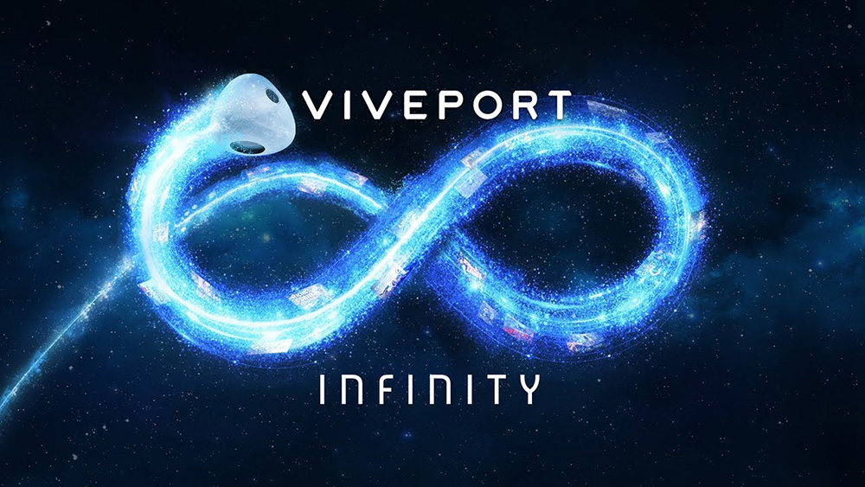

TEAM 11

TODD TOWNSEND, ABRAM FOUTS, KARLA BARRAZA LOPEZ, WENHAO CHENG, XUENING JIA

Sponsor: Brad Smith - Intel Corporation

Advisor: Fu Li

## **February 7th, 2020**

Hey Dr. Li,

Here is a brief review of what has gone on this week. Today we presented our proposal to Mark and Andrew. We haven't split off into separate sections, so this will cover what we all have done.

We have completed a PDS that is current to our level of knowledge of the project. We finally got a license for Unity, and plan on getting the old code working soon. We also finished our proposal presentation, and received approval from Brad. We have been looking more into the API of the code for the Vive. We will be receiving the Vive headset February 15th (at least that was Brad's self proclaimed deadline). The headset that we are receiving screen doesn't work, but that's okay because we can see everything we need on the computer.

Once we get the hardware we need a location to store all of our gear, so we don't have to set it up every time we want to use it. Brad mentioned previously that a room in the robotics lab was used. Can you help us set this up?

Thanks,

Capstone Project Odin 2.0

## 

## **February 26th, 2020**

Hey Fu Li,

We missed a weekly update, but there hasn't been too much progress in the development of our project. We have been doing a lot of research with the software we are going to be using and the API, but we haven't received the hardware yet. This Friday (2/28/20) we will be going to Intel to get and demo our new hardware. We have the old hardware working in Unity on our personal machines too. We have a good understanding of what needs to be done to make a significant amount of progress once we have our new hardware. The only potential roadblocks we may encounter are getting the correct drivers and other necessary software to make the hardware work on our work station from Intel.

We have been doing weekly meetings together and weekly meetings with Brad from Intel.

Thanks,

(A)Bram Fouts & Odin II

## **March 6th, 2020**

Hey Fu Li,

Here's another weekly update on the ODIN 2.0 project. We finally have the new VR gear from intel along with a computer to run it. We are now located in the Special Projects Lab within the Robotics Lab, and we plan on having our team meetings in there from now on (unless another team is in there).

We are starting to separate tasks, but currently we setting up all of the necessary software on our system. We were finally given internet access this afternoon, and we plan on having everything running Monday. We have the VR environment set up inside of our room, and now it's time to get into the nitty-gritty work and build a virtual environment that coincides with our VIVE. We are looking at parenting different objects within unity to track movements of the headset, so we can create our own eye tracking calibration. There are still some unknowns that exist. Whether or not the default Vive tracking takes in consideration that the user may have a lazy eye.

Thanks,

Abram Fouts & ODIN 2.0

## 

## **March 16th, 2020**

We got the VR gear from Intel along with a computer to run it. We tried to set up VR, and performed a simple operation. It worked pretty well. Moreover, we are going to have our weekly meeting in the robotic lab (70-07). This week, We are starting to separate tasks. Here are the details: Field Of View(FOV): We studied what FOV is. In VR devices, the field of view refers to the field of view in the horizontal direction.

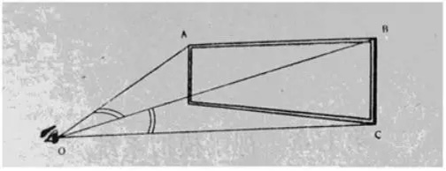

For example, in the figure, the angle AOB is the horizontal field of view. In the real world, a person's normal field of view angle is 110 degrees. When it exceeds 110 degrees, people usually turn their heads to see. We also studied the function of FOV. The size of the field of view directly affects the clarity and immersion of the field of view. Immersive refers to the fact that we are in the VR headset. FOV is embodied in the process of the scene entering the eye through the lens. For instance, if the eye looks at an object through the VR lens, if the design is proper, you can see the entire object, and the size of the field of view corresponds to the height of the character. The highest and lowest rays we can see are refracted into the eye through the lens, and the angle between the two refractive lines is FOV.

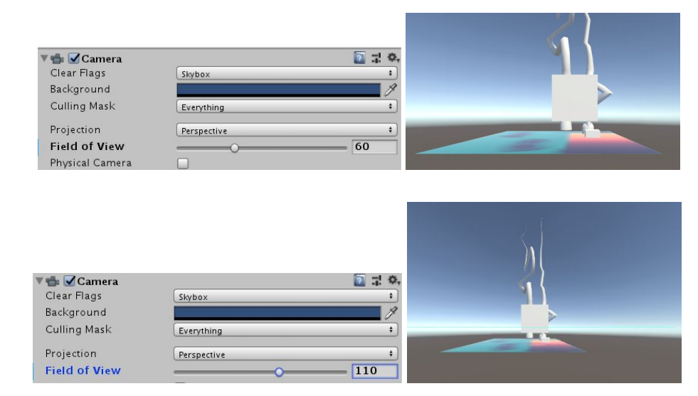

When we set the object, we place the object under the camera and set its relative coordinates to 0. This can be used as a reference coordinate. For the amblyopic group, the gaze vector tracked by their eyes is not correct. At this time, we need to analyze the correct gaze vector based on the data(Normal person gaze vector). When we get the correct fixed vector, we need to use the controller to move it to the plane we can render. In this way, the function of correcting amblyopia can be achieved. Now that we understand the basics, we are now looking at Unity API for programming. We are now studying how to connect the controller and the gaze vector.

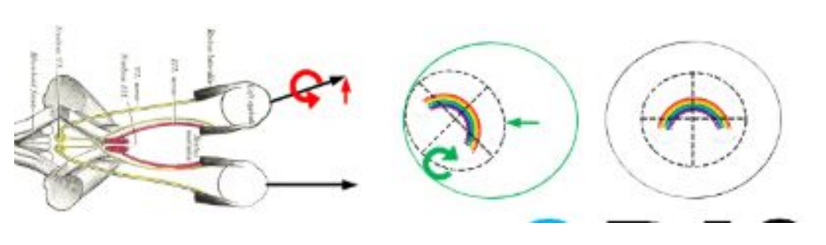

Bram and Karla are working on the touch controllers and getting them implemented into Unity. We are learning how to have each button perform a specific action, and we are learning how to extract the position and rotation value from the HTC VIVE hardware. Todd is working on extracting the gaze vectors from the TOBII eye tracking software/hardware inside of the VR headset. Each task that the team members are working are our three main deliverables to Intel.

## **April 24th, 2020**

Hi Fu Li,

I realise it's been a while since we updated you on how our project is going, but with everything moving to remote it stinted our development until very recently. Previously we discussed how we tasked everyone with parts of the project. This was near the dead week of Winter quarter. We have only been able to research since then, but we could not have any hands on access to our hardware. Unfortunately we needed hands on access. Up until this week we haven't had any hardware access. Our hardware has been shipped to Brad Smith's house and we are remote accessing it, and he is assisting us in the testing. The deliverables have changed given the state of COVID-19. Our must deliverables have almost been achieved which includes an eye tracking vector hook, and a touch controller hook. We plan to have these complete in the next few days. The part that changed was manipulating the field of view of each eye. Wenhao and Xuening have made good progress, and we are going to assist them in the development of this hook once we finish our assigned tasks. Again, sorry for the long wait in replies, we felt there wasn't enough development happening to prompt an update,

Regards,

Team ODIN II

## **May 8th, 2020**

Hi Fu Li,

Here's a brief update of what's going on in the ODIN II project. We have fully working touch controller input hooks ready for Intel. Todd has been working vigorously on finishing up the gaze vector hooks (retrieving said vectors became a larger challenge than expected), and we believe it's down to debugging our reference code. Since this is an ongoing developing area there are API changes happening FREQUENTLY. From when we first started the project now SteamVR has gone from 2.0 to 2.2 and professional developers are still learning the changed API. A lot of references are to SteamVR 2.0 which limits where we can get assistance/documentation. From what we can tell, we are some of the few (maybe only) attempting to use the gaze vectors detected in the head mounted display.

Karla is debugging some extra touch controller input, and Xeuning and Wenhao are in the process of manipulating the frustums so we can change the FOV per eye in the HMD. This is also a challenge because there is very little documentation on this, and it's very possible it's been outdated with the coming of SteamVR 2.2. On the plus side, our industry advisor Brad seems very pleased with the development we've created given the circumstances of everyone's quarantined lives.

Have a good weekend,

Bram Fouts & ODIN II

## **May 31st, 2030**

Hey Fu Li,

This appears to be the final project update before we present everything to you. I'm going to run down what we accomplished and what we fell short of. We were able to complete the gaze vector and touch controller parts of the project, but we were not able to fully manipulate the FOV. We were able to adjust rotation of each eye but not the frustums. This was expected and accounted for in scheduling because of the remote access of COVID. We wanted to get live updates on the controller 3D position and rotation, but we failed this too. This wasn't required, but we wanted to attempt to receive all controller data.

We receive each gaze vector from each eye and we are able to create a custom IO function for each controller. We are currently finishing up all of our documentation, slide shows, and log book for our project. We have a lot of useful content for whoever we pass this project onto.

Regards,

Bram Fouts & ODIN II

Directions:

#### **Weekly Progress Reports**

Weekly progress reports play a crucial role in team communication and keeping a project on track and on schedule. Each week on a day agreed to by your industry sponsor and/or faculty advisor you need to send an email containing your weekly progress report (WPR). The e-mail should be sent to each of your teammates as well as your industry sponsor and faculty advisor. It's a good idea to cc: yourself so that you have a record and can include them in your project notebook. It's a good idea to make the subject line of your WPR e-mail include your project name and the keyword "WPR" along with the period covered (e.g. the week ending date).

Your weekly report should be brief but contain:

* A brief refresher on the overall project, your part in the project, and your specific tasks and goals from the prior week
* An explanation of what actions you took and what you accomplished
* A description of what problems you encountered and how you solved them
* A discussion of problems remaining and your thoughts on possible solutions
* Your action plan for the following week